InSite Design Specification
Version 1.0

Project/Department:  Project Name | InSite Project  InSite
Issue Date: | 09 May, 2014
Owner: | IBS Vietnam
Author: | Hoa Tran

Document Reviewer Information
Reviewer Name | Review Attendance (R/S) | Comments
Yoshihito Satoyoshi | 2014/07/22 | Review Security
R/S: Required or Suggested participants or functions for the document review meeting.

Document Approver Information
Approver name | Approver Function | Comments

Table of Contents
1. Introduction 5
1.1 Overview 5
1.2 Document Conventions and abbreviation 5
1.3 Document Scope 5
1.4 Reference 5
2. Overall Description 6
2.1 System Environment 6
2.2 Risks and Volatile Areas 6
3. Architecture 7
3.1 Overview 7
3.1.1 User Architecture Diagram 7
3.1.2 Detail Architecture Diagram 7
3.1.3 User authenticate procedure flow chart 8
3.1.4 Local storage description 8
3.1.5 SSL 8
3.1.6 Log 9
3.1.7 Description of Components/Interfaces 9
3.2 Third Party Description 9
4. Component Design 10
4.1 Use Case Diagram 10
4.1.1 Login 10
4.1.2 View dashboard page 11
4.1.3 Update project condition 11
4.1.4 View issue list 11
4.1.5 Update issue detail 12
4.1.6 Add group 12
4.1.7 Edit group 12
4.1.8 Delete group 12
4.1.9 Add project 12
4.1.10 Edit project 13
4.1.11 Delete project 13
4.2 Component Dependencies Diagram 13
4.3 Interface Description 13
4.4 INSITE Sequence Diagram 14
4.4.1 Login 14
4.4.2 View dashboard 15
4.4.3 Update project condition 16
4.4.4 View issue list 17
4.4.5 Update issue detail 18
4.4.6 Add group 19
4.4.7 Edit group 20
4.4.8 Delete group 21
4.4.9 Add project 21
4.4.10 Edit project 22
4.4.11 Delete project 23
5. User Interface Design 24
5.1 Screen Presentation 24
5.1.1 Login 24
5.1.2 Dashboard 25
5.1.3 Project condition 26
5.1.4 Issue list 27
5.1.5 Issue detail 28
5.1.6 Add group 29
5.1.7 Edit group 30
5.1.8 Delete group 32
5.1.9 Add project 33
5.1.10 Edit project 34
5.1.11 Delete project 36
6. Deployment Model 38
7. Operational Supporting Mechanism 38
8. Restrictions, Limitations, and Constraints 38
9. Security 39
10. Testing 40

Introduction

Overview
This is a design in high level for INSITE application. The INSITE is a solution to report the status of projects. The user can report the status of project by many conditions and view the status overview. The software need to be compatible with iOs and Android environment.

Document Conventions and abbreviation
Name | Descriptions
INSITE | Project Name
IBS | Intelligence Business Solutions
InSite | Application Name

Document Scope
This document does not carry out the detail design for every component like all classes, constant, structure variables, etc…, it covers at high level design which helps developer knowing what will be implemented including system architecture, main components, main class, layout and frameworks to implement.
The document is separated in two phases and put in milestones 1 & 3.
Milestone 1:
- System architect model
- Components relationship
- Describe basic screen shots for INSITE application. The screen is used to describe of application behavior
Milestone 3:
- Use case diagram
- Class diagram,
- Sequence diagram

Reference

Overall Description

System Environment
The following are description of frameworks, tools, operation system, servers and libraries which are used in in application development.
Categories | Technologies
Technical | Phonegap 2.9.1
Languages | HTML, jquery 1.10.2, jquery mobile 1.4.2, php
Tool | Eclipse, genny motion
Operation System | iOS and Android
Language Server | Sumfony 1.4
Database server | Postgress 9.3

Risks and Volatile Areas
#Risk | Description
Design | - Design implications is not sufficiently considered in concept exploration  - System will not satisfy user requirements
Schedule | - Project schedule changes due to the change of requirements
Requirement | - Lack of analysis for changing of requirements due to the change extension of requirements
Development | - Development is not sufficiently considered during design

Architecture

Overview

User Architecture Diagram

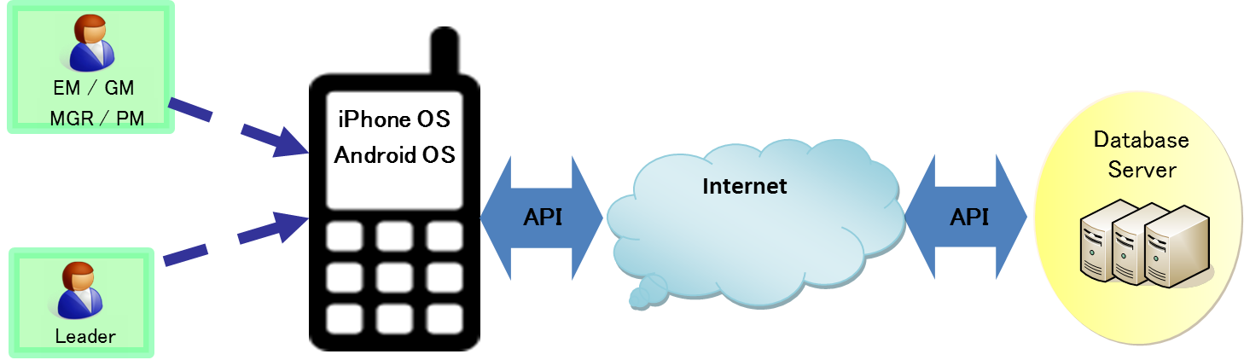

Detail Architecture Diagram

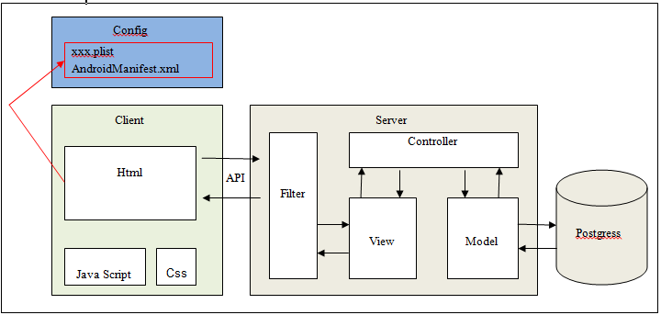

User authenticate procedure flow chart

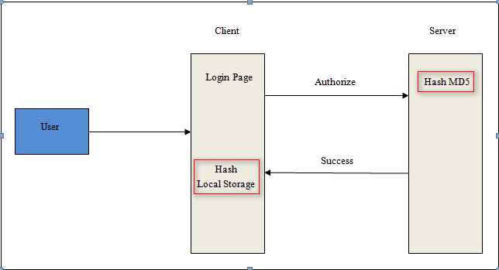

Local storage description

All data stored with “Local Storage” is kept on that one mobile, and only accessible by the app you used to create the data.
- “Local Storage" allows one to save data as “key-value” pairs
- There are 4 kinds of “Local Storage” stored in our app:
+ Role Id
+ Group Id
+ Project Id
+ Password

SSL
- SSL (Secure Sockets Layer) is the standard security technology for establishing an encrypted link between a web server and a browser. This link ensures that all data passed between the web server and browsers remain private and integral. SSL is an industry standard and is used by millions of websites in the protection of their online transactions with their customers.
- Our Application : all requests from application to sever are HTTPS, app cannot connect to port 80, app can connect to port 443

Log
All CRUD operations that error happen will be written into log file: “apislm_dev.log”
Format log file below:
[‘yyyy-MM-dd HH:mm:ss' : - RoleId:[‘ RoleId’] - ProjectId:[‘ProjectId’] - Method:[ ‘Method Name’]. Error: ‘Error Message’]
Example:
2014-08-23 10:02:58 - RoleId:[1] - ProjectId:[0] - Method:[executeAddproject()]. Error: Couldn't find class tprj001sa

Description of Components/Interfaces
Name | Description
Login | This component is responsible for logining to system, checking the login role and inputed password.
Dashboard | This is the main user interface of application to view How many projects have red, yellow, green and No report status.
Issue list  Issue details | This component is responsible for viewing the issue list and issue details. Which each issue details, user can add more feedback comment to review or resolve the issue.
Project condition | This component is responsible for sending the project conditions to server. Each project condition have red, yellow and green status to report. If user choose red or yellow status, application will add this condition into issue list with comment. Leader will report weekly the status of project by Project condition component.
Setting | This component is responsible for setting group and project (add, edit and delete). Each project belong to one group.

Third Party Description
Name | Description
Phonegap 2.9.1 | Phonegap is an open-source mobile development framework. It allows you to use standard web technologies such as HTML5, CSS3, and JavaScript for cross-platform development, avoiding each mobile platforms' native development language. Applications execute within wrappers targeted to each platform, and rely on standards-compliant API bindings to access each device's sensors, data, and network status.  Refer link: http://phonegap.com/
Jquery 1.10.2 | jQuery is a fast, small, and feature-rich JavaScript library. It makes things like HTML document traversal and manipulation, event handling, animation, and Ajax much simpler with an easy-to-use API that works across a multitude of browsers. With a combination of versatility and extensibility, jQuery has changed the way that millions of people write JavaScript.  Refer link: http://jquery.com/
Jquery 1.4.2 | Query Mobile is a HTML5-based user interface system designed to make responsive web sites and apps that are accessible on all smartphone, tablet and desktop devices.  Refer link: http://jquerymobile.com/

Component Design

Use Case Diagram
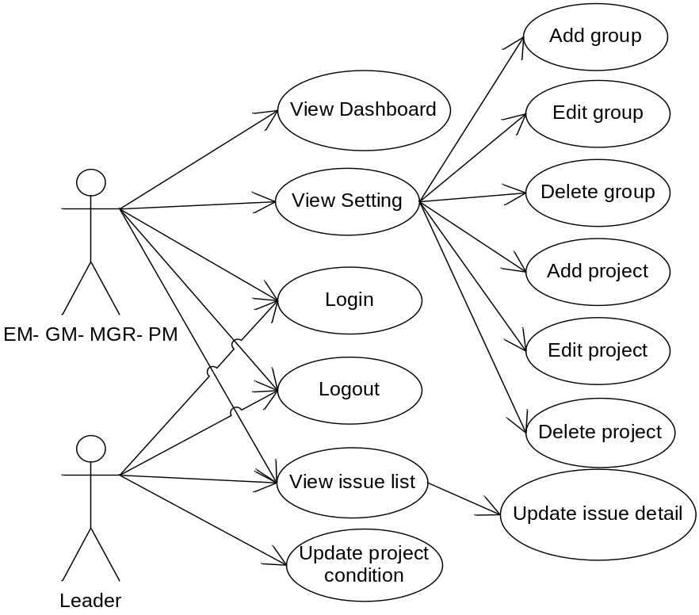
Figure 4: INSITE case diagram

Login
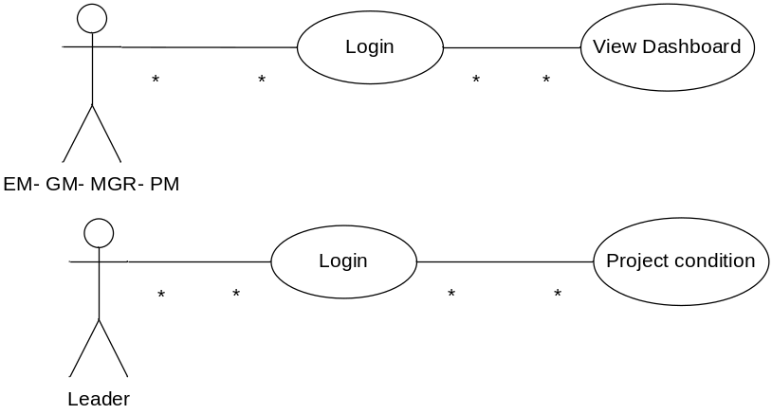

UC01: Login INSITE application

View dashboard page

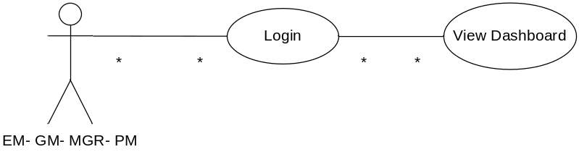
UC02: View dashboard page

Update project condition
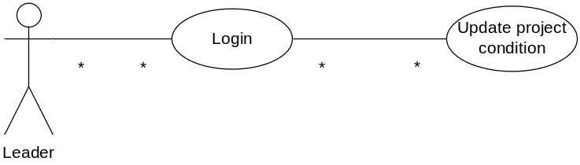
UC03: Update project condition

View issue list
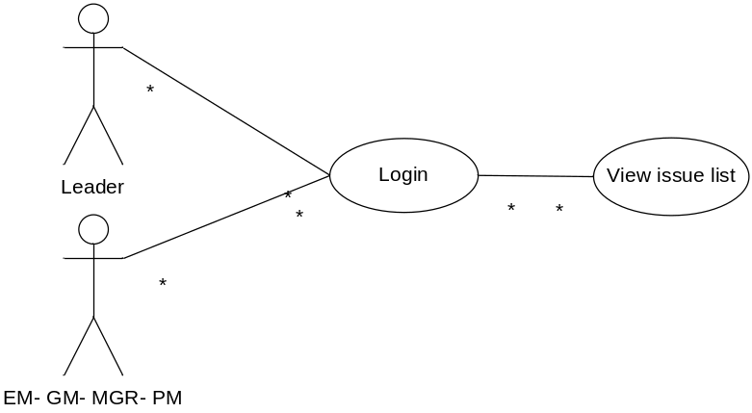
UC04: View issue list

Update issue detail
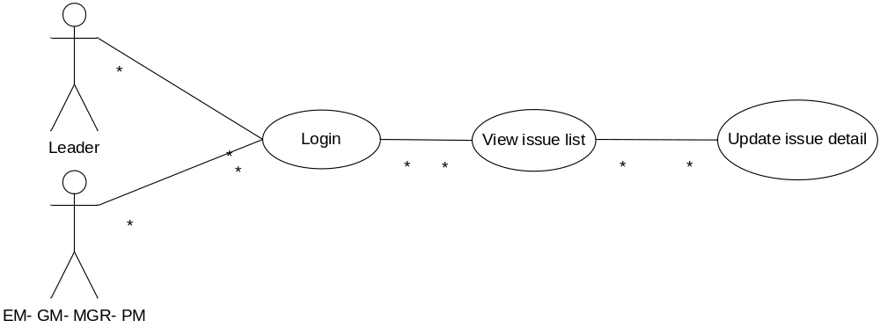
UC05: Update issue detail

Add group
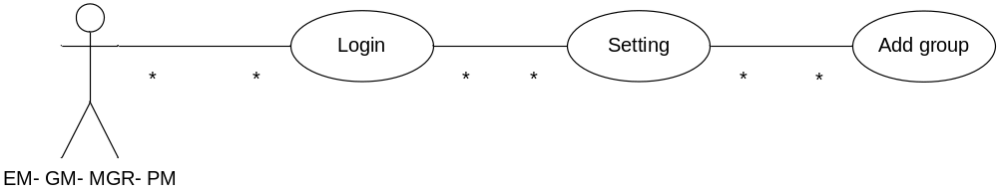
UC06: Add group

Edit group

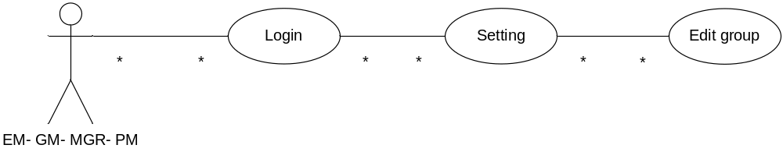
UC07: Edit group

Delete group
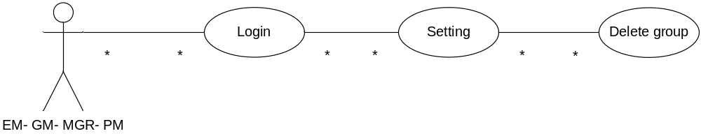
UC08: Delete group

Add project
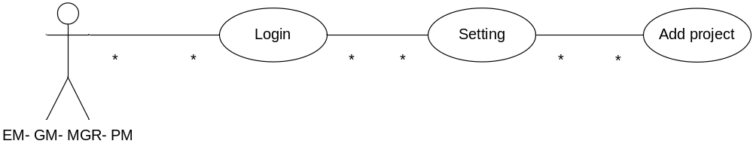
UC09: Add project

Edit project
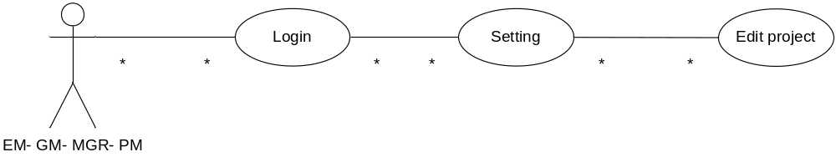
UC10: Edit projecy

Delete project
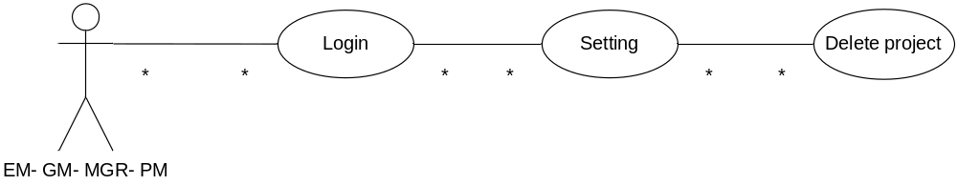
UC11: Delete project

Component Dependencies Diagram
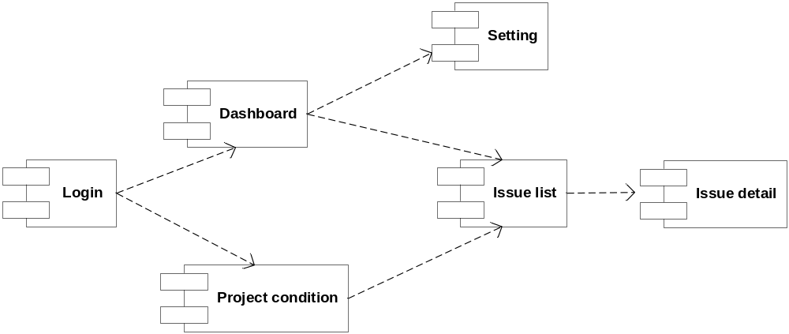
Figure 5: Component diagram

Interface Description

INSITE Sequence Diagram

Login
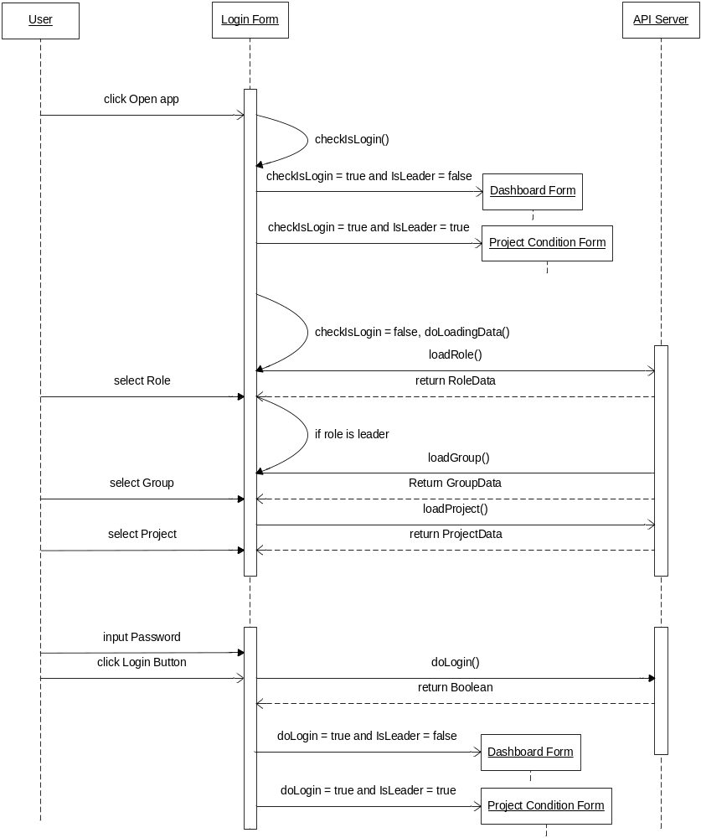
Figure 1: Login Sequence Diagram

View dashboard

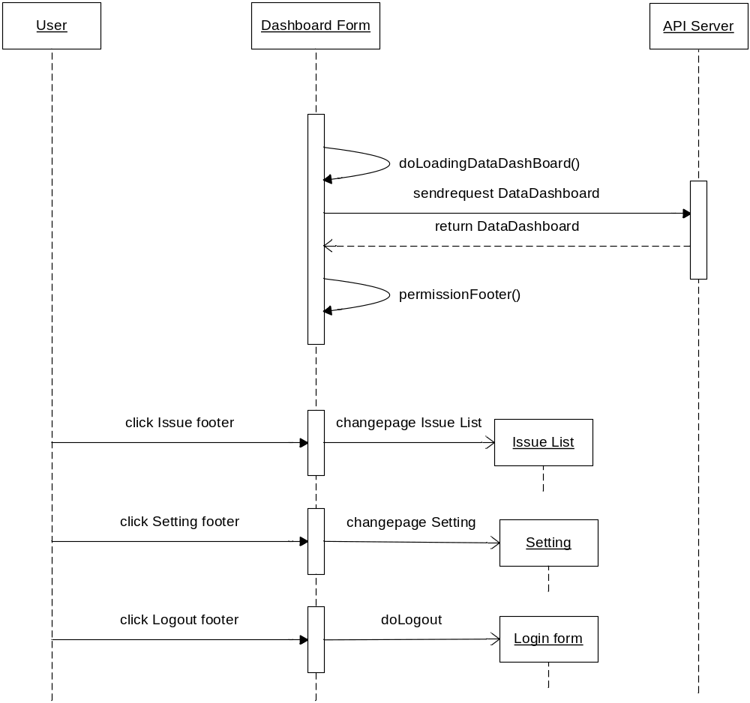
Figure 2: Dashboarch Sequence Diagram

Update project condition

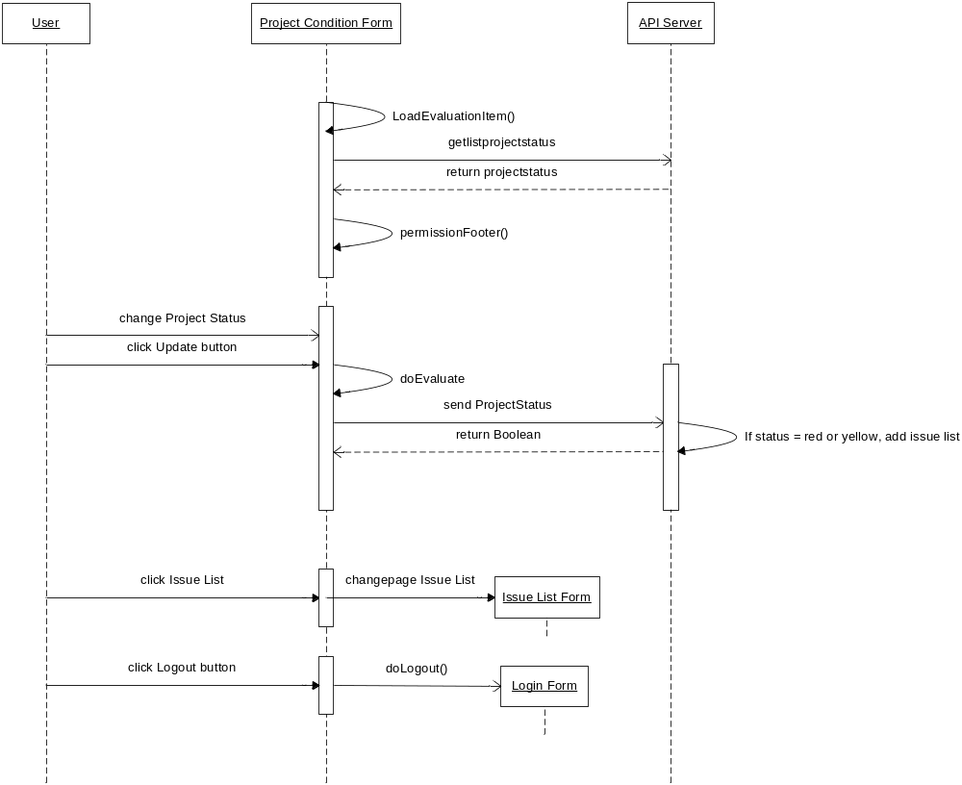
Figure 3: Project Condition Sequence Diagram

View issue list

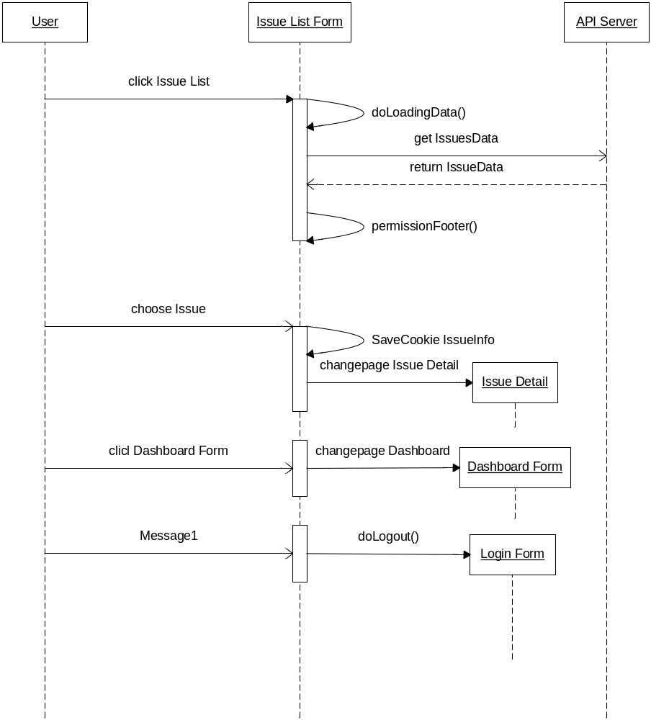
Figure 4: Issue List Sequence Diagram

Update issue detail

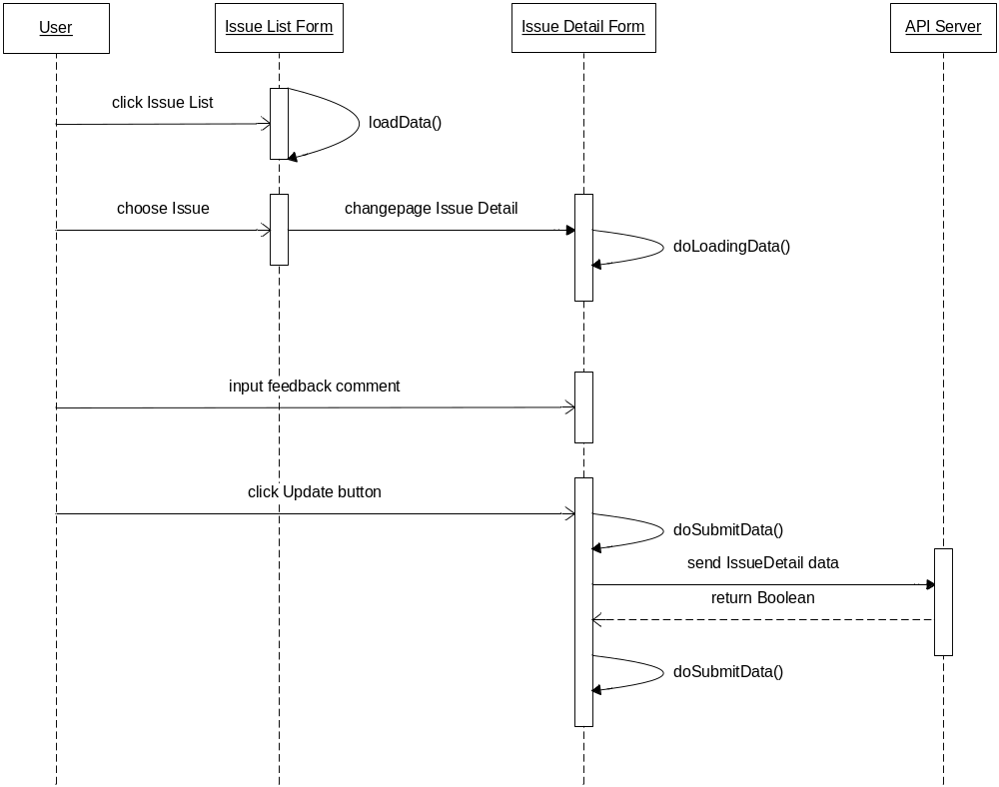
Figure 5: Update Issue Detail Sequence Diagram

Add group

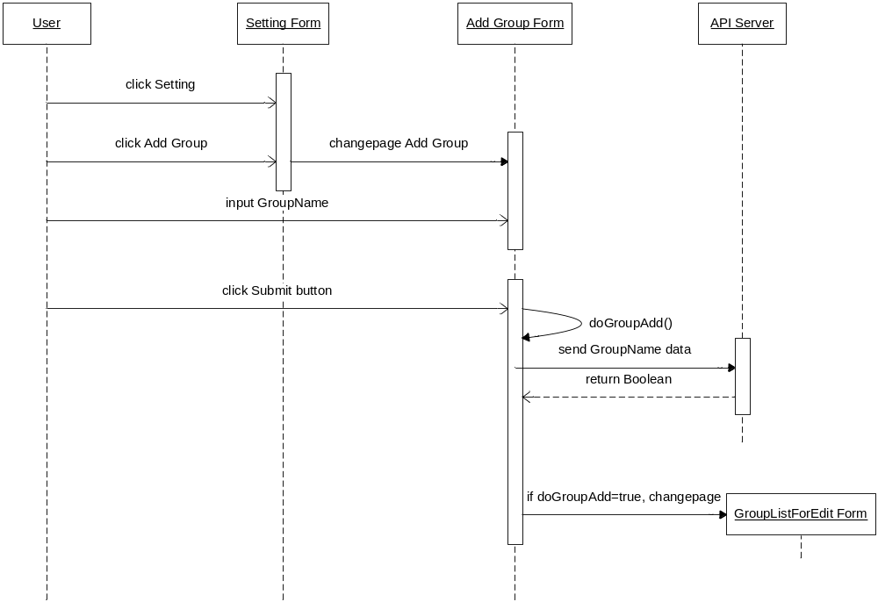
Figure 6: Add Group Sequence Diagram

Edit group

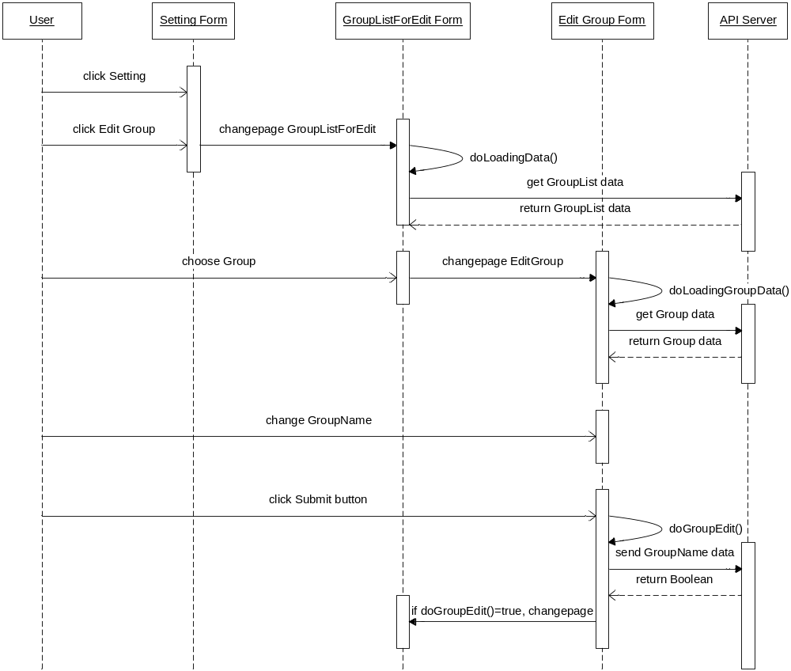
Figure 7: Edit Group Sequence Diagram

Delete group
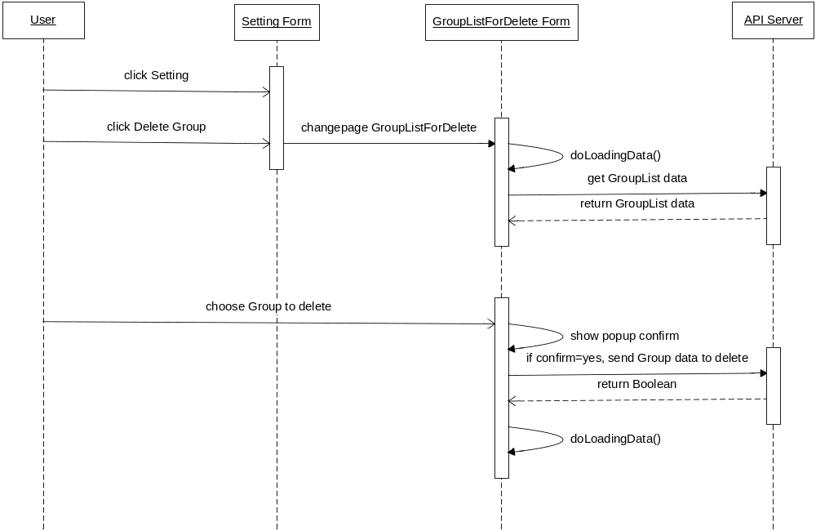
Figure 8: Delete Group Sequence Diagram

Add project

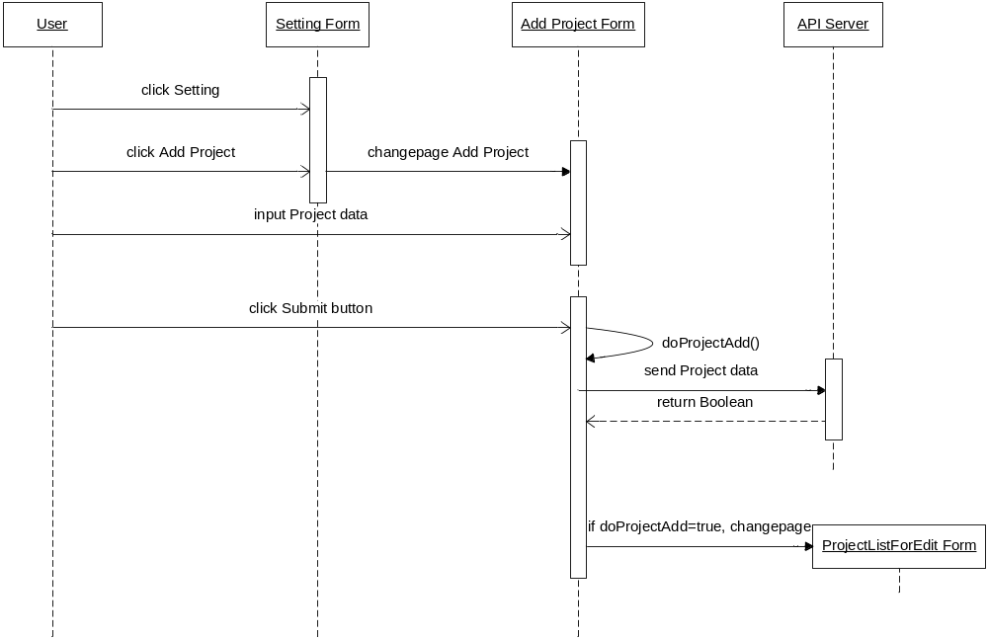
Figure 9: Add Project Sequence Diagram

Edit project
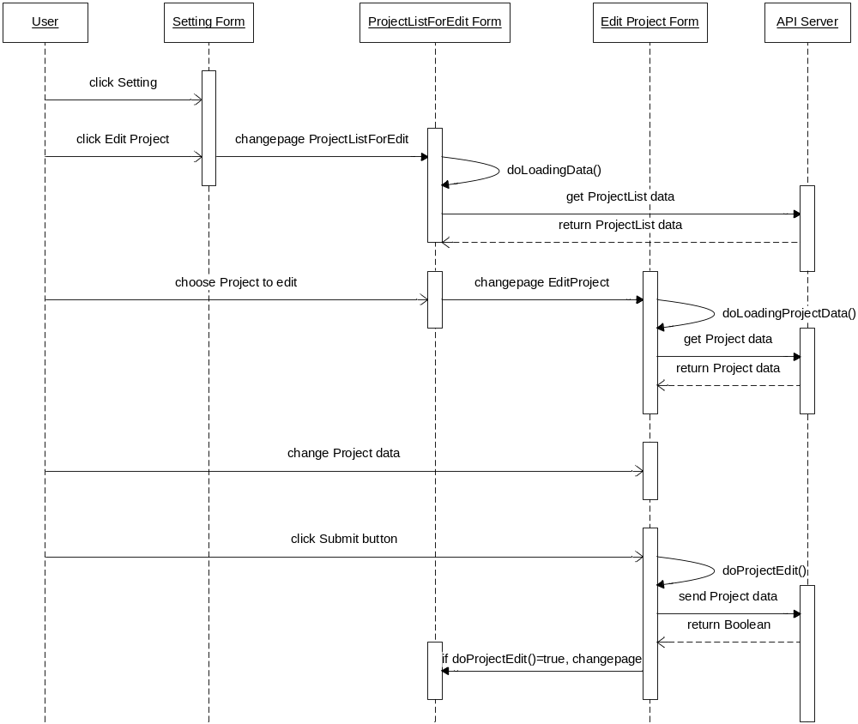
Figure 10: Edit Project Sequence Diagram

Delete project
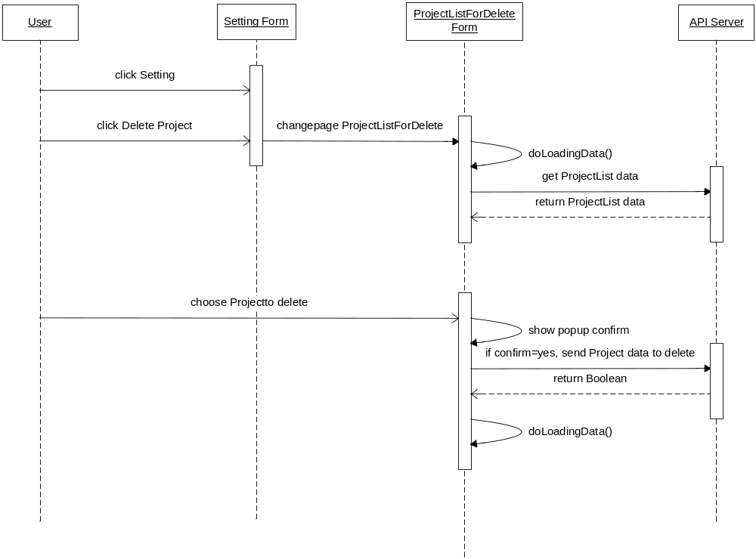
Figure 11: Delete Project Sequence Diagram

User Interface Design
The InSite application comprises a user interface to make user’s interaction as simple and efficient as possible. The InSite application supports user interface for report the status of project, view the status of project by weekly.

Screen Presentation

Login

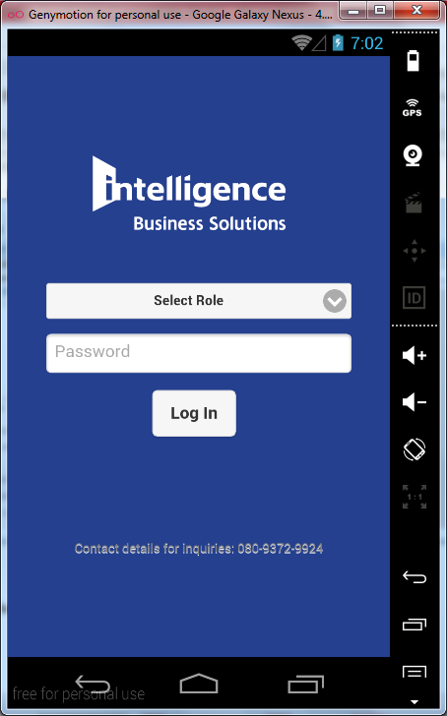
Figure 5.1.1: Login

Dashboard

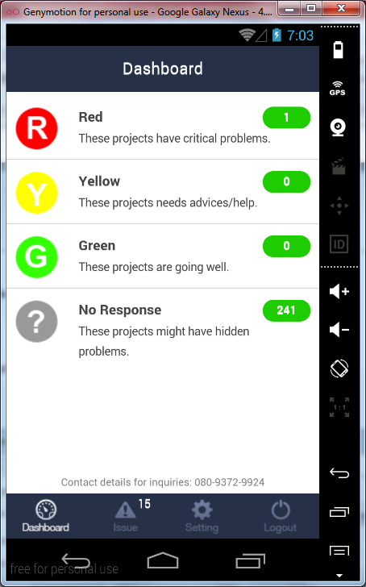
Figure 5.1.2: Dashboard

Project condition
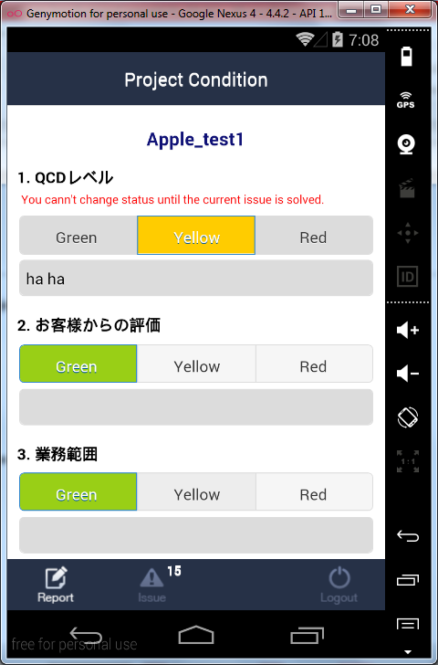
Figure 5.1.3: Project condition

Issue list
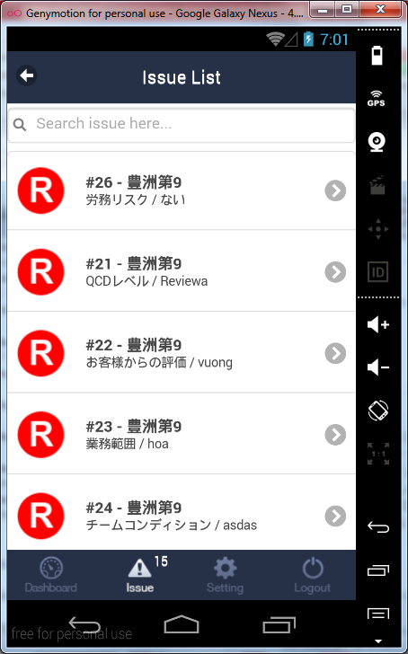
Figure 5.1.4: Issue list

Issue detail

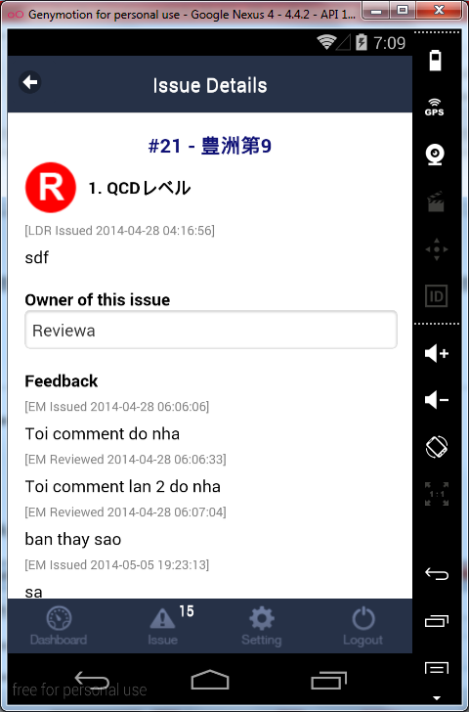
Figure 5.1.5: Issue detail

Add group

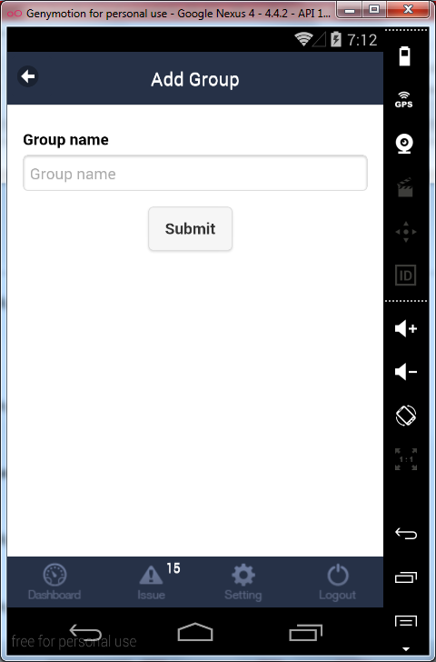
Figure 5.1.6: Add group

Edit group
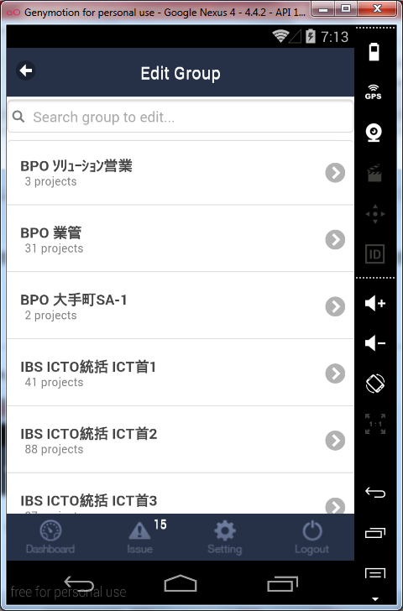
Figure 5.1.7.1: Group list to edit

Figure 5.1.7.2: Edit group

Delete group

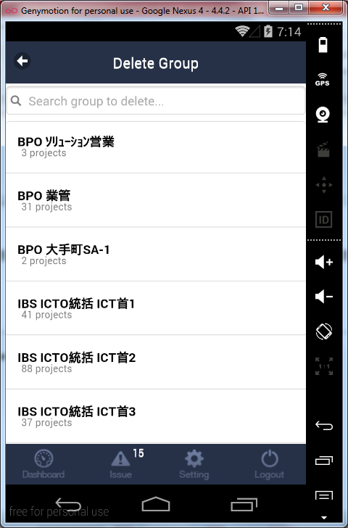
Figure 5.1.8: Delete group

Add project

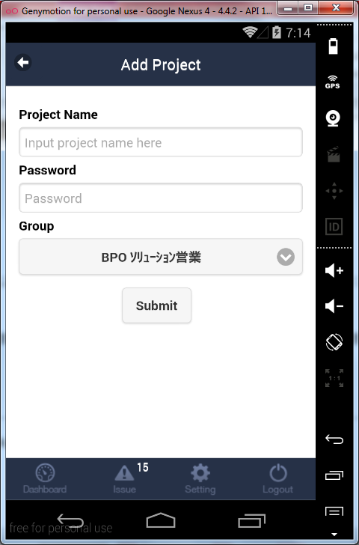
Figure 5.1.9: Add project

Edit project

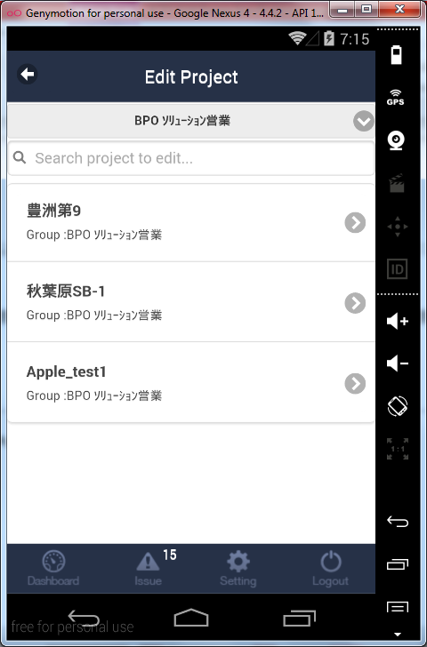
Figure 5.1.10.1: Project list to edit
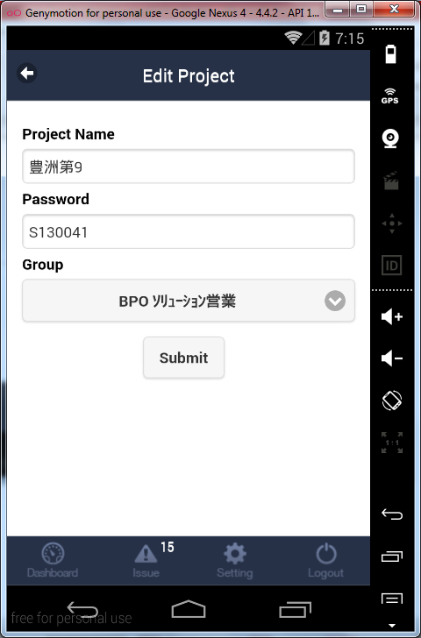
Figure 5.1.10.2: Edit project

Delete project

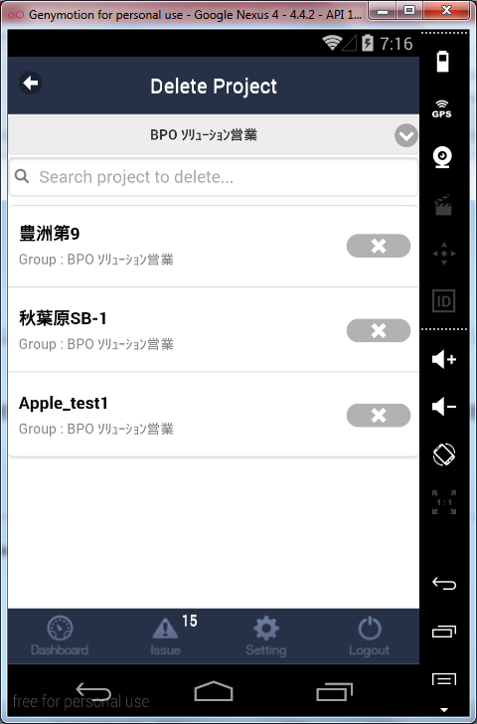
Figure 5.1.11.1: Project list to delete
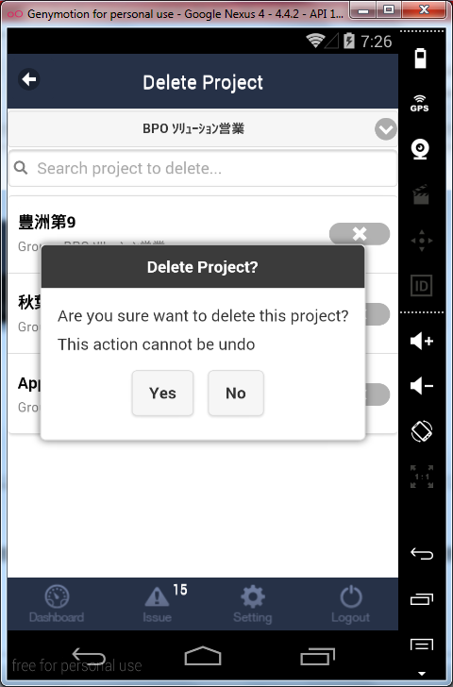

Figure 5.1.11.2: Delete project

Deployment Model
The INSITE application will be packaged and update to Android and iOS store.

Operational Supporting Mechanism

Restrictions, Limitations, and Constraints

Security
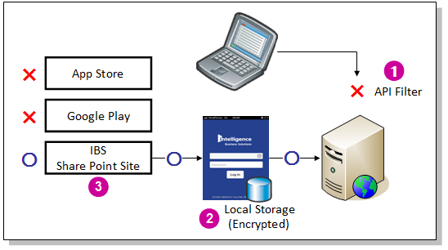
Type | Description
1. API security | Anyone can not access to the API without using InSite application. Because :  1. All API's URL has to have a static key.  2. This static key is in InSite and API server.  3. The API filter (key checker) is executed for every URL request.
2. Local Storage security | Anyone can't read a user id and password from “Local Storage”. Because:  1. We have to save user id and password in “Local Storage” for auto login.  2. InSite store encrypted user id and password to "Local Storage".  3. Even if someone (some application) can access to Local Storage, user id and password are encrypted.
3. Install security | Anyone can't install application unless having INTE account.  Because:  1. We can’t install InSite from App Store and Google Play  2. We can download InSite installer from IBS Share Point Site. At that time we have to login to this Share Point Site with INTELLIGENCE account.

Testing
- The test will be conducted for each function before a task is set to complete

---------- End of Document ----------

